Bio301
Q1: what are chromosomal aberration hw do we clasify them 10
A chromosome anomaly, abnormality, aberration, or mutation is a missing, extra, or irregular portion of chromosomal DNA.[1] It can be from an atypical number of chromosomes or a structural abnormality in one or more chromosomes. Chromosome mutation was formerly used in a strict sense to mean a change in a chromosomal segment, involving more than one gene.[2] A karyotype refers to a full set of chromosomes from an individual that can be compared to a "normal" karyotype for the species via genetic testing. A chromosome anomaly may be detected or confirmed in this manner. Chromosome anomalies usually occur when there is an error in cell division following meiosis or mitosis. There are many types of chromosome anomalies. They can be organized into two basic groups, numerical and structural anomalies.
types
The three major single chromosome mutations; deletion (1), duplication (2) and inversion (3). The two major two chromosome mutations; insertion (1) and Translocation (2). A chromosome anomaly, abnormality, aberration, or mutation is a missing, extra, or irregular portion of chromosomal DNA.
http://mcb.berkeley.edu/courses/mcb142/lecture%20topics/Dernburg/Lecture6_Chapter8_screenviewing.pdf
Q2: Point mutation?revrs frwrd r nutrel mutation ?5 marks ka ta
A point mutation, or single base modification, is a type of mutation that causes a single nucleotide base substitution, insertion, or deletion of the genetic material, DNA or RNA. The term frameshift mutation indicates the addition or deletion of a base pair.
Point mutation is a random SNP (single-nucleotide polymorphism) mutation in the deoxyribonucleic acid (DNA) that occurs at one point. Point mutations usually take place during DNA replication. DNA replication occurs when one double-stranded DNA molecule creates two single strands of DNA, each of which is a template for the creation of the complementary strand. A single point mutation can change the whole DNA sequence. Changing one purine or pyrimidine may change the amino acid that the nucleotides code for.
Point mutations may arise from spontaneous mutations that occur during DNA replication. The rate of mutation may be increased by mutagens. Mutagens can be physical, such as radiation from UV rays, X-rays or extreme heat, or chemical (molecules that misplace base pairs or disrupt the helical shape of DNA). Mutagens associated with cancers are often studied to learn about cancer and its prevention.

Bio301
Q1: what are chromosomal aberration hw do we clasify them 10
A chromosome anomaly, abnormality, aberration, or mutation is a missing, extra, or irregular portion of chromosomal DNA.[1] It can be from an atypical number of chromosomes or a structural abnormality in one or more chromosomes. Chromosome mutation was formerly used in a strict sense to mean a change in a chromosomal segment, involving more than one gene.[2] A karyotype refers to a full set of chromosomes from an individual that can be compared to a "normal" karyotype for the species via genetic testing. A chromosome anomaly may be detected or confirmed in this manner. Chromosome anomalies usually occur when there is an error in cell division following meiosis or mitosis. There are many types of chromosome anomalies. They can be organized into two basic groups, numerical and structural anomalies.
types
The three major single chromosome mutations; deletion (1), duplication (2) and inversion (3). The two major two chromosome mutations; insertion (1) and Translocation (2). A chromosome anomaly, abnormality, aberration, or mutation is a missing, extra, or irregular portion of chromosomal DNA.
http://mcb.berkeley.edu/courses/mcb142/lecture%20topics/Dernburg/Lecture6_Chapter8_screenviewing.pdf
Q2: Point mutation?revrs frwrd r nutrel mutation ?5 marks ka ta
A point mutation, or single base modification, is a type of mutation that causes a single nucleotide base substitution, insertion, or deletion of the genetic material, DNA or RNA. The term frameshift mutation indicates the addition or deletion of a base pair.
Point mutation is a random SNP (single-nucleotide polymorphism) mutation in the deoxyribonucleic acid (DNA) that occurs at one point. Point mutations usually take place during DNA replication. DNA replication occurs when one double-stranded DNA molecule creates two single strands of DNA, each of which is a template for the creation of the complementary strand. A single point mutation can change the whole DNA sequence. Changing one purine or pyrimidine may change the amino acid that the nucleotides code for.
Point mutations may arise from spontaneous mutations that occur during DNA replication. The rate of mutation may be increased by mutagens. Mutagens can be physical, such as radiation from UV rays, X-rays or extreme heat, or chemical (molecules that misplace base pairs or disrupt the helical shape of DNA). Mutagens associated with cancers are often studied to learn about cancer and its prevention.
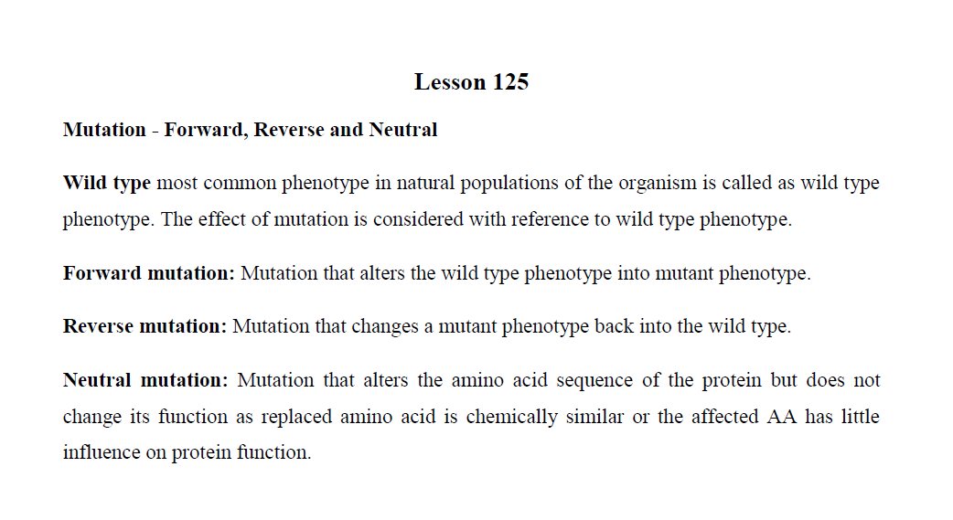

Q3:enlish variations ocure due to change in chromosome
Numerical changes
➢ Aneuploidy

Hypo ploidy
Hyper ploidy
➢ Euploidy Monoploidy

Diploidy
Polyploidy
Structural
➢ Translocations
➢ Deletions
➢ Duplications
➢ Inversions

Different cell lines
➢ Mosaicism
Q4:What is epigenetics
the study of changes in organisms caused by modification of gene expression rather than alteration of the genetic code itself.
Five complications in inhertianc patteren [check lecture no.157]

How mutation alter gene function[check lecture No. 136]

SUBJECTIVE 40 MARKS
Q5:.Write the modification of epi genetics ? 10
Epigenetic modifications are crucial for packaging and interpreting the genome under the influence of physiological factors [4-8]. Epigenetics is one of the fastest-growing areas of science and has now become a central issue in biological studies of development and disease [3, 7-11]. In recent years, there have been rapid advancees in the understanding of epigenetic mechanisms [12-14], which include histone modifications [4-6, 15], DNA methylation [10, 11, 16, 18], small and non-coding RNAs [20, 56], and chromatin architecture [13, 15, 21]. These mechanisms, in addition to other transcriptional regulationary events [15, 17], ultimately regulate gene activity and expression during development and differentiation, or in response to environmental stimuli [16, 17].
Epigenetic research can help explain how cells carrying identical DNA differentiate into different cell types, and how they maintain differentiated cellular states [14, 17]. Epigenetics is thus considered a bridge between genotype and phenotype [1-3, 7, 9].
While epigenetics refers to the changes of single genes or sets of genes, the term epigenome reflects the overall epigenetic state of a cell, and refers to global analyses of epigenetic markers across the entire genome [3, 14]. It is therefore critically important to map the epigenetic modification patterns or profile the epigenome in a given cell, which then can be used as epigenetic biomarkers for clinical prediction, diagnosis, and therapeutic development [8, 11, 18, 45]. International human epigenome projects are currently working to catalog all the epigenetic markers in all major tissues across the entire genome. The resulting reference maps will usher in epigenetics as an exciting new era of medical science [14]. As an example of the research community's commitment to classifying epigenetic markers, the National Institutes of Health (NIH) has recently launched a $190 million research effort to learn more about epigenetics.
This mini-review focuses on DNA methylation and the predominant histone modifications, with emphasis on their dynamic interactions within the chromatin environment to form the complex epigenetic mechanisms that orchestrate the regulation of genes at the molecular level in mammalian cells.

